TWO APPROACHES FOR STUDYING SINGLE COUPLED SECOND ORDER CELL CNN'S
Tiberiu Dinu Teodorescu, Liviu Goraş
Technical University Iasi, Romania
Faculty of Electronics and Telecommunications
Email: t-teodor@etc.tuiasi.ro, lgoras@etc.tuiasi.ro

ABSTRACT
In this communication a comparison between two approaches for studying single-coupled CNN’s is presented. First is related to so-called dispersion curve and second to the approach introduced in [1], which handles the stability problem through the roots locus method.
First method may be used for studying double-coupled CNN’s as well, while the second is suited only for single-coupled CNN’s, but opens new analytical options for studying this kind of systems, due to it’s generality.
Both methods are based on decoupling technique, and valid for the central linear part of the non-linear cell.

INTRODUCTION
Since their invention [2], many significant results regarding the CNN behavior have been obtained.
One of the methods for patterns studying and filtering capabilities makes use of the decoupling technique, which is valid for dynamics, restricted to the central linear part of the cell characteristics. This method is fundamentally linear and has been applied for the study of the linear filtering properties of the first order cell and second order neighborhood template as well as for the pattern formation in second order cell first order neighborhood template.
The aim of this communication is to make a comparison two approaches for stability analysis. One is related to the dispersion curve method connected with the window – method [] and the other to the roots locus method and using a certain part of the roots locus method in connection with the so-called template.
First method was related with certain circuit implementations of the cell [3] and is known related to Turing patterns where the template was fixed to discrete laplacean. The second is focused mainly on the general implementation of the CNN cell, which is modeled by means of a second order impedance coupled with the neighbors be means of voltage-controlled current sources as in the figure below. This approach is a general one because of the fact that the cell may be in general considered an uniport with certain impedance.

The impedance may have any shape and any order.
Y(s)
Bu_{i-1}
Bu_{i+1}
u_{i}

Figure 1: General CNN cell coupled with first order neighbors.
Systems obtained by using other shapes for the above-mentioned impedance are introduced in [1] and are subjects for further studies using roots locus method.

DISPERSION CURVE METHOD
$\begin{aligned}\left\{\frac{{\text{du}}_{i}(t)}{\text{dt}}=γ(f_{u}u_{i}+f_{v}v_{i})+D_{u}O_{1D}(u_{i}) i=0\text{.}\text{.}M−1 | \right.\end{aligned}$In the following we consider two-port cells connected by means of two identical first order neighborhood templates. In the central linear part, the CNN is described by the following set of equations

(1)

where O_{1D} has the shape (for symmetrical templates):
$O_{1D}(u_{i})={\text{Bu}}_{i−1}+{\text{Bu}}_{i+1}+{\text{Au}}_{i}$(2)
$\begin{aligned}\left\{u_{i}=\sum_{m=0}^{M−1}{Φ_{M}(m,i)\overset{\hat{}}{u_{m}} i=0\text{.}\text{.}M−1}\right.\end{aligned}$Using the decoupling technique, by means of the change of variable:

(3)

$Φ_{M}(ω(m),ϕ(m),i)=e^{j(ω(m)i+ϕ(m))}$where :
(4)

$K_{1D}(m)=A+2B\text{cos}(ϖ(m))$the spatial eigenvalues are (see also figure 2):
(5)

and $\begin{aligned}\text{Re}(λ_{1,2}(K_{1D}))= \\ \text{Re}\left\{γ\frac{f_{u}+g_{v}}{2}+\frac{D_{u}K_{1D}}{2} | | ±\sqrt{{\left[γ\frac{(g_{v}−f_{u})}{2}−\frac{D_{u}K_{1D}}{2}\right]}^{2}+γ^{2}f_{v}g_{u}}\right\}\end{aligned}$the dispersion curve for a single layered CNN is:

(6)

The curves in Fig. 1 represent the locus of the real part of the solutions above.

Figure 2: Dispersion curves for a single layer CNN
The imaginary parts of the temporal eigenvalues are represented in Fig. 3:

Figure 3: The imaginary part of the eigenvalues
The dispersion curves exhibit a central region with complex roots and two lateral regions with real roots.
According to the shape of the curves and the domain of the eigenvalues various types of dynamics are possible. The difference between this case and the double-coupled CNN’s is that one cannot obtain a horizontal middle zone except for the situation when D_{u}=0, which is the case when the cells are no more connected. In addition, one cannot obtain extremum points for the dispersion curve in the single-coupled CNN case.
Several relevant points on the above dispersion curves are:
$\begin{aligned}K_{1D_{\text{left}}}=\frac{γ}{D_{u}}\left[(f_{u}−g_{v})−2\sqrt{−f_{v}g_{u}}\right] \\ K_{1D_{\text{right}}}=\frac{γ}{D_{u}}\left[(f_{u}−g_{v})+2\sqrt{−f_{v}g_{u}}\right]\end{aligned}$The extremities of the zone where the eigenvalues are complex conjugated,

(7)

${ΔK}_{1D}=−\frac{4γ\sqrt{−f_{v}g_{u}}}{D_{u}}$The width of the central zone:

(8)

$K_{1\text{Dmiddle}}=−\frac{γ}{D_{u}}\left(f_{u}−g_{v}\right)$The center of the central zone:

(9)

$\text{Re}(K_{1\text{Dmiddle}})=\frac{γ g_{v}}{2}$and

(10)

From (7) and (8) one can easily see that the necessary condition for the middle zone to exist (K_{1Dleft} and K_{1Dright} to be real numbers) is that the product f_{v}g_{u} have negative sign. When f_{v}g_{u}=0, there is only one value K_{1D} for which the temporal eigenvalues are complex conjugated.
$\begin{aligned}\text{Im}(λ_{1,2}(K_{1D}))= \\ \sqrt{{\left[γ\frac{(g_{v}−f_{u})}{2}−\frac{D_{u}K_{1D}}{2}\right]}^{2}+γ^{2}f_{v}g_{u}} \\ \end{aligned}$The imaginary part curve (in the case it exists) gives the frequency of the temporal oscillations for each mode:

(12)

Selecting a region under the dispersion curve (window) is possible by appropriately choosing the template parameters according to equation (5).

Figure 4: Selecting a window by using template parameters A=1 and B=-1 from dispersion curve in Fig. 2. (the real part)
The imaginary part of this part of the dispersion curve is represented in Fig. 5:

Figure 5: Selecting a window by using template parameters A=1 and B=-1 from dispersion curve in Fig. 3. (the imaginary part)

ROOT LOCUS METHOD
$Y(s)=s−γ f_{u}−\frac{γ^{2}f_{v}g_{u}}{s−γ g_{v}}$The admittance for the description of the cell introduced in Fig. 1 for the case of Chua cell [2, 4] may be written in the following form:
(13)

$(Y(s)−K_{1D}^{'}(m)){\hat{u}}_{m}$When coupling the cells with a grid one obtain the decoupled equations:
(14)

$1−K_{1D}^{'}\frac{s+β}{s^{2}+2α+ϖ_{0}^{2}}=0$The equation above becomes for the case of single coupled second order CNN:

(15)

$\begin{aligned}α=−\frac{γ}{2}(f_{u}+g_{v}) \\ β=−γ g_{v} \\ ϖ_{0}^{2}=γ^{2}(f_{u}g_{v}−f_{v}g_{u})\end{aligned}$where

(16)

By using the equation (15) one can sketch the roots locus and discuss the stability of the CNN depending on the value of K’_{1D}. The value of K’_{1D} is the same function of modes as in equation (5). Consequently, the points of the roots locus may be labeled with modes.
Some of them will be placed in the left part of the complex plane and others will stay in the right part. The points located in the right part of the complex plane will correspond to unstable modes, while the other points on the root locus plot will correspond to stable modes.
One roots locus plot is displayed below:

Figure 6: Roots locus when K’_{1D} is located inside the interval [-0.5 1.5] (the equivalent of window method for roots locus method)

SIMULATION RESULTS
The simulations have been done with the following set of parameters: γ=5, fu=0.1, gu=0.1, fv=-1, gv=-0.2, Du=0.5. Fig. (2-5) represents the dispersion curve(s) for this set of parameters.
In Fig. (6) the root locus for this set of parameters is displayed, according to equations (13-16).
As one can see, the range for the real parts of the modes last from –0.5 to 0.5 in both representations in Fig. 4 and respectively 6. The imaginary part lies in the interval -1.5, 1.5 in both sets of representations (see Figs 5 and 6).
According to the window method (see Figs.2 and 3) one have isolated the part of the dispersion curves located between the values –1 and 3 of K_{1D}. All the roots of the characteristic polynomial are complex conjugated inside this interval. Accordingly, when sketching the root locus in Fig. 6, one must take into account that the “strength” of the connection of each cell with the neighbors is multiplied with Du in equation (1).
$K_{1D}^{'}=D_{u}K_{1D}$Consequently, the relationship between K_{1D} and K’_{1D} may be written as in the equation displayed below:
(17)
The equation (17) suggests that D_{u} is not necessarily an independent parameter. Other parameters aren’t independent as well.
The equivalent values for root locus parameters method are: α=0.25, β=1 and ω₀²=2.
One present a set of simulations for the system described above.
First, a simulation for the system described by equation (1), presents the evolution in time of the state variables at port u. The state variables (voltages on capacitors) where all zero except for the state variable in the middle of 1D network, which had initially, value 0.1 (Fig. 7)
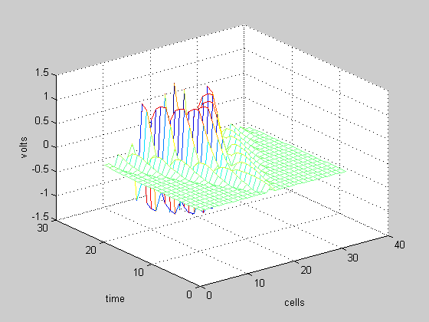
Figure 7: Time evolution for the CNN made with second order cells as in equation (1)

In Fig. 8 the simulation done by using the general simulator designed for the general case gave the same result in the linear part:

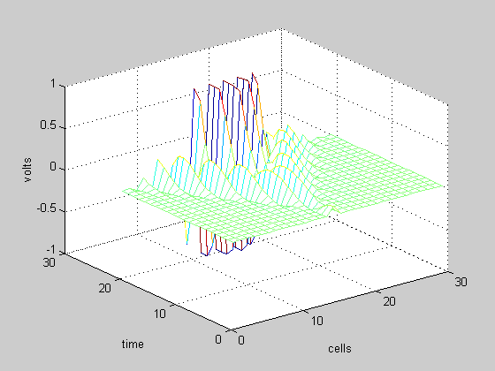
Figure 8: Time evolution for the CNN made with second order cells as a particular case of a general impedance (equations 13 –15)

CONCLUDING REMARKS
As a conclusion to our presentation, one can say that the root locus method is suitable for a specific class of cellular neural networks: single-coupled CNNs. The main advantage of this method is the fact that the cell can be modeled as an impedance of any order. The drawback is that one cannot analyze double-coupled CNNs by using this method.
The dispersion curve method is powerful only for impedances with shapes as in the equation 15, but it has the advantage of being successfully used for double-coupled CNNs.
Both analysis methods are also design methods for their class of systems.

REFERENCES
[1] L.Goras, T.D. Teodorescu – „On the Dynamics of a Class of CNN”, to be publisehd in SCS’01 Proceedings, Iasi, 2000, Romania
[2] L.O.Chua, L. Yang – "Cellular Neural Networks: Theory", IEEE Transactions on Circuits and Systems, vol. 35, number 10, October 1988,pp 1257-1272
[3] L. Goras, L.O. Chua – “Turing Patterns in CNNs – Part II: Equations and Behaviors”, IEEE Transactions on Circuits and Systems, vol. 42, number 10, October 1995,pp 612-626.
[4] K.R. Crounse, "Ph. Thesis: Image Processing Techniques for Cellular Neural Network Hardware", University of California, Berkeley, Fall, 1997

